Windows 7/Office 2010 Outlook/Word/Excel
Quick Reference Guides

Windows 7

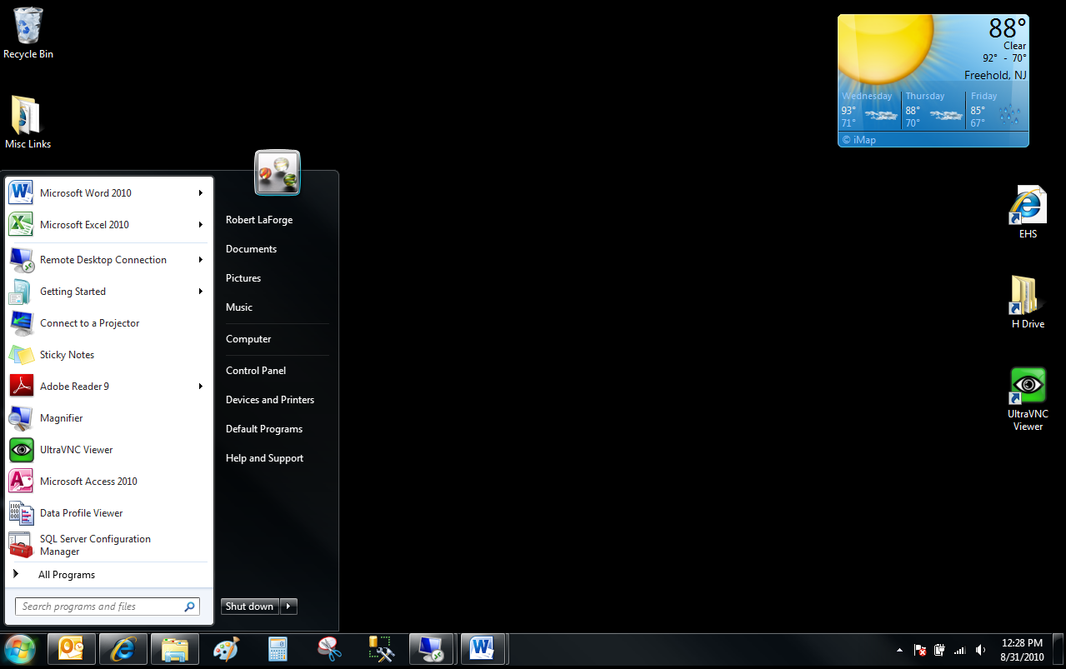
System Tray
Stacked icon
Pinned programs
Recently opened
Arrow opens Jump List
Custom menu item
Shut down
Desktop icon
Gadget
Show Desktop
Taskbar

Unopened icon
Search Box
Opened icon

Aero Snap
Click and hold on top of window and drag to an edge. When cursor touches edge then window will snap to fill one half of the screen.
Aero Shake
Click and hold on top of window and shake window, all other windows will minimize. Shake again and the other windows will restore.
Aero Flip
Alt+Tab and then tab through open windows to select top one. Use Windows key+Tab for 3D flip.
Pin programs
Pin programs to Start Menu or Taskbar by right clicking. Can drag a program to the desktop to create a shortcut.
Jump List
On Start Menu (use arrow) or Taskbar (right-click) shows most recent documents.

Search
Preview button
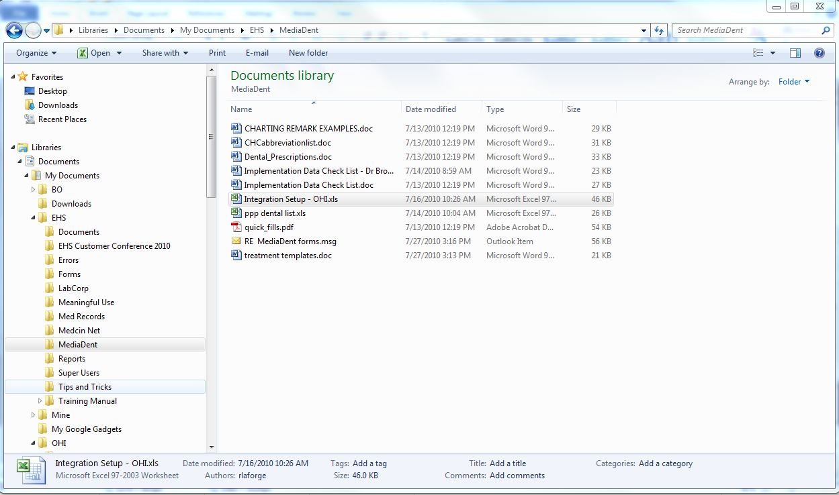
Address Bar
View button
Arrange by
Details Pane
Menu Bar
Library Pane
Navigation Pane
Start Menu
Press Windows key to bring up the Start Menu
View Files in Folder
To change the size and details of files in a folder click the down arrow of the View button
Preview files
Click the Preview button so that the preview opens on the right side of the screen then when you click on a file you will see a preview
Address Bar
Can click on any folder to navigate back or click on right-most arrow (if available) to see immediate sub-folders
Quick E-mail document
Click on the file then click E-mail on the menu bar at the top
Search
What you type in the Search box will search filenames, tags, and contents. You can filter by clicking on the Search box and clicking one of the filters in blue
Add/Remove Panes
Can add or remove panes by opening the Organize menu (far left on the Menu Bar), opening Layout, and checking or unchecking a pane

Outlook 2010

Ribbon
Tabs
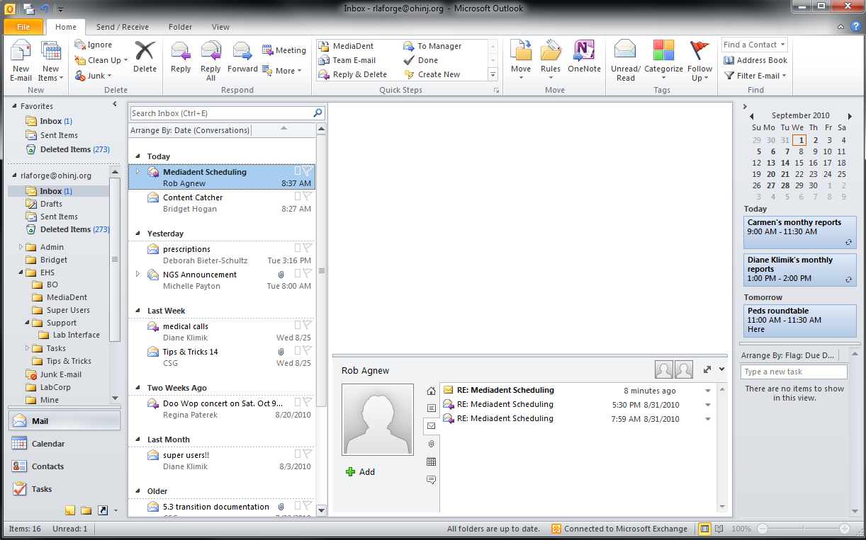
Navigation Bar
E-Mail List
Reading Pane
People Pane
To-do Bar
Group
Dialog Box arrow
View buttons
Zoom
Search
Current Appts
Quick Links
People Pane categories
Date Navigator
Tasks
Print
File (Backstage View)/Print or Ctrl-P
Meetings
- On To-do bar click on a date on the calendar (Date Navigator)
- On an e-mail click Home/Meeting
- On Quick Links click on Calendar/Home/New
New E-mail
Home/New
Reply, Reply All, Forward
Home/Respond
Delete
Home/Delete
Create new contact group
Contacts, Home/New/New Contact Group
People Pane
To set to Normal, Minimized, or Off go to View/People Pane
Preview Attachments in Reading Pane
Click on the attachment and then click the “Preview file” button. To get back to the message, click the “Message” button on the top left of the Reading Pane.
Key Tips
Click the Alt key on your keyboard
Signature
Create a new message and then go to Home/Include/Signatures. Click “Add” button
BCC
While in a new message, Options/Show Fields (will then appear in all subsequent messages unless you choose to not show it again
Ignore
While on an e-mail where you want to have all subsequent messages automatically deleted: Home/Delete
Conversations
To turn on: View/Conversations -> Check the “Show as Conversations” box
Clean Up
Home/Delete/Clean Up -> Will delete all redundant messages
Out of Office Message
File/Info/Automatic Replies
New Contact
Contacts (Quick Link)/New/New Contact
New Contact Group
Contacts (Quick Link)/New/New Contact Group
Creating a contact based on a received message
Right-click on a name or e-mail address in the From, To, or CC fields and choose “Add to Outlook Contacts”
Quick Access Toolbar
To Add: On the ribbon, right-click the icon and choose “Add to Quick Access Toolbar”
To Remove: On the Quick Access Toolbar, right-click the icon to remove and choose “Remove from Quick Access Toolbar”
Share Calendar
Calendar (Quick Links)/Share/Share Calendar
Quick Steps
Located at Home/Quick Steps are one-click ways to preform common tasks. Can customize by clicking the dropdown arrow and choosing “Manage Quick Steps…”
Address Book
Home/Find (far right side of Ribbon)
Tasks
To add a task to your To-do Bar open Tasks (Quick Links) and type in your task, then hit <Enter>. To change the date, use Home/Current View and choose “Next 7 Days” and change Due Date. To complete a task, click on the flag.
Filter E-mail
Home/Find/Filter E-mail and use the dropdown box

Word 2010

Selected Shortcuts
CTRL + A | Select All |  | CTRL + S | Save
CTRL + B | Bold selected text |  | CTRL + U | Underline
CTRL + C | Copy |  | CTRL + V | Paste
CTRL + E | Center text |  | CTRL + X | Cut
CTRL + F | Find |  | CTRL + Z | Undo last action
CTRL + H | Replace |  | CTRL + ENTER | Insert page break
CTRL + I | Italic |  | F1 | Get help
CTRL + N | New document |  | F7 | Spell check
CTRL + O | Open file |  | Shift + F7 | Thesaurus
CTRL + P | Print |  | F12 | Save as

Esc
Use Escape key to back out from any place
Print
File (Backstage View)/Print
Navigation Pane
View/Show -> Check “Navigation Pane” or CTRL+F
Search: Type search phrase in “Search Document” box and click <ENTER>
Click Search Results button to see all results; can click on a result to go there
Click Previous and Next arrows to go to other search results
Click dropdown arrow on Search Box to search for specific objects such as graphics, tables, etc
Navigate using headings
Navigate using pages
Page Layout
Margins (Normal, Narrow, Wide, etc.)
Orientation (Portrait, Landscape)
Columns
Track Changes
Review/Tracking
Clipboard
Home/Clipboard dialog arrow
Quick Parts
To Copy: Insert/Quick Parts/Save Selection to Quick Part Gallery…
To Insert: Insert/Quick Parts -> May show up in box -or- Insert/Quick Parts/Building Blocks Organizer…
To Manage: Insert/Quick Parts/Building Blocks Organizer…
Table
Insert/Tables

Excel 2010

F1 | Help |  | CTRL + V | Paste
F2 | Edit the current cell |  | CTRL + Z | Undo
F7 | Spell checker |  | CTRL + Page up | Move to previous worksheet
F11 (select data 1st) | Launch Chart Tools |  | CTRL + Page down | Move to next worksheet
F12 | Save As |  | CTRL + P | Print
CTRL + A | Select all |  | CTRL + 9 | Hide current active row
CTRL + C | Copy |  | CTRL + 0 | Hide current active column
CTRL + X | Cut |  | CTRL + spacebar | Select entire column
Shift + spacebar | Select entire row |  | CTRL + Shift + ; | Current time into cell
CTRL + ; | Current date into cell |  | Alt + = | Inserts SUM and adds up all numeric cells above
CTRL + B | Boldface |  | CTRL + i | Italics
CTRL + U | Underline |  | CTRL + 5 | Strikethrough
CTRL + Shift + ! | Comma format |  | CTRL + Shift + $ | Currency format
CTRL + Shift + % | Percentage format |  | CTRL + Shift + ^ | Scientific format
CTRL + Shift + @ | Time format |  | CTRL + T | Insert table

Print
File/Print
Recent Files
File/Recent (can pin)
Merge Cells
Home/Alignment/Merge & Center
Font, Colors, Alignment, Column/Row Formatting, Text Orientation
All on Home tab
Mini-Toolbar
Select cells then right-click
Tables, Charts, Pictures
All on Insert tab
AutoSum
Select cells, Formulas/AutoSum
Sorting and Filtering
Select all cells (click top-left box-left of “A” and above “1”), Data tab, Sort & Filter
Format as Table
Select Cells, Home/Styles/Format as Table
Improved Paste Options
Home/Paste
Pivot Table
Select cells, Insert/Tables/Pivot Table, choose where to paste, OK, design table

