

Many times we deliberately appear differently than who we really are. At a job interview we act more professionally. We are serious at a funeral but are loose and uninhibited at a party. These are expected masks that we wear for special occasions.

On certain holidays, we put on real masks simply to have fun, but other times, like when committing a crime, it is done to hide ourselves so that we will not be caught.
What is the purpose of a mask? It is to disguise ourselves so that others will not recognize us or to appear to be something else.

But there is one time when this can be deadly. When confronted with who God is and what He has said many of us put on a mask. We disguise ourselves because we know that one day we will stand before God and in that great moment a judgment will be made—will we spend an eternity in Heaven or in Hell? This verdict will be based solely on a choice we made while we were still alive.

That choice was whether to put on a mask or to face God honestly and believe what He says.

What are some of these masks and are you wearing one of them?

The Religion Mask
This is where you think that as long as you go to church or belong to a denomination you are acceptable in God’s eyes. In John 3:3 Jesus says otherwise, “Truly, truly, I say to you, unless one is born again, he cannot see the kingdom of God.” Have you been born-again?

The Self-Sufficiency Mask

You have made it this far in life without needing anyone’s help and so you certainly do not need God’s help now. However, in John 14:6 Jesus said, “I am the way, and the truth, and the life; no one comes to the Father, but through Me.”


The Good Person Mask
You have seen a lot of bad people and you are not one of them. In fact, you consider yourself to be pretty good. But
Ephesians 2:8-9 reads, “For by grace you have been saved through faith; and that not of yourselves, it is the gift of God; not as a result of works, that no one should boast.”


The Intellectual Mask
You have weighed all of the science versus faith arguments and you believe that science wins and there is no God. Psalm 19:1 tells us differently, “The heavens are telling of the glory of God; and their expanse is declaring the work of His hands.”

The Ignorance Mask

You have never really cared much about spiritual matters but you believe that God will not hold that against you. Romans 1:20, “For since the creation of the world His invisible attributes, His eternal power and divine nature, have been clearly seen, being understood through what has been made, so that they are without excuse.”

The Guilty Mask

You have been quite a bad person and you do not think that God could ever for give you. But Colossians 2:13 tells us that when we were dead in our sins God “made you alive together with Him, having forgiven us all our sins.”


The Honesty Mask
What does it mean to be honest with God? It means admitting what our true nature is really like. The Bible tells us who we really are. It tells us that we are made in the image of God and are infinitely valuable and precious in His sight. But it also tells us that we are sinners. But what is sin?
Sin is breaking a law. Some laws are from human authorities. Break company rules and you may be fired. Break a governmental law and you may go to jail.
Then there are God’s laws. Some are positive: show mercy, read your Bible, go to church, help the poor. Some are negative: do not lust, steal, hate, or gossip. We have all broken at least one of God’s laws either by not doing what we should do or by doing something that we should not do.
The greater the authority the greater the penalty. God is perfectly and infinitely holy. Therefore, the penalty for even one sin is infinitely costly and we cannot pay it. We owe God a great debt.
But we cannot be good enough to pay off this debt. We need help. That is why Jesus Christ died on the cross; so that He could pay the entire penalty of each and every one of our sins. Colossians 2:13-14 says, “And when you were dead in your sins…, He made you alive together with Him, having forgiven us all our sins, having canceled out the certificate of debt consisting of decrees against us and which was hostile to us; and He has taken it out of the way, having nailed it to the cross. Then three days later He rose from the dead.
Once we admit this what should we do? We must confess Jesus Christ as Lord and receive, through faith, His payment for our sins. That is being born-again. Once we are forgiven we know that when we eventually stand before God our judgment will be for Heaven. God guarantees this.
Who are you? That is for you to determine. What you can choose to be, if you are honest, is a child of God, completely forgiven of all of your sins, and confidently destined for an eternity in Heaven.


Would you like to know more?
We’d love to help!
Please contact us



Which person are you?

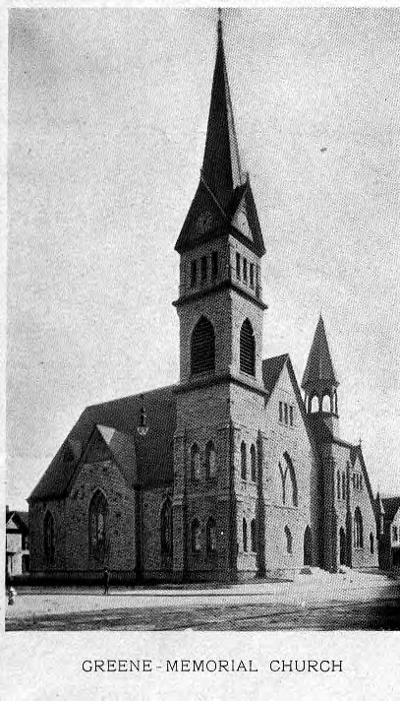
Guilty

Intellectual

Religious

Honest

Ignorant

Good Person

