Why should I care about religion?
Truth matters. When we live according to the truth we will do well. Religion says that certain decisions that you make or do not make will have an eternal effect on your existence. Suppose that there is a Heaven and a Hell. What will happen to you if you make the wrong choice or that making no choice at all is the same as saying “no”? Suppose you find out at the end that shrugging your shoulders and admitting, “I guess I goofed” is not good enough? That would be a terrible price for not caring.
And religion matters for today. In Matthew 5 there is a list of ways that we can be blessed: by being gentle, merciful, pure in heart, a peacemaker and so on. Life is hard; we need all of the blessings that we can get. If we do not care about the abundance and meaning that God wants to give to us then we certainly have no reason to complain about our lot in life.
Why should I care about the Bible?
We can only know supernatural truth through Divine revelation. We may know that there is a God through nature but we can only know who and what He is by what He has written to us.
The Bible tells us everything about God that we need to know to have a personal relationship with Him.
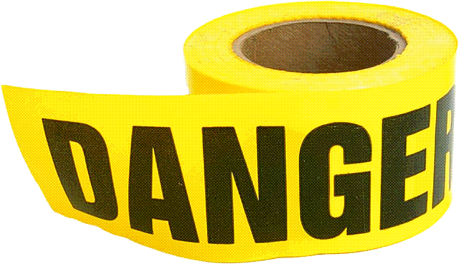
Why should I
care about
what happens
to me after I die?
Why go to school or have a job? Why take vitamins or exercise? Why buy clothes or food? It is all because you want a better future. Much of our lives are spent creating a safer, more comfortable future. We plan for weekends but we ignore eternity. If the Devil can keep you delaying a crucial decision until it is too late then he has won.
The end of your life will come. Even if you are young and that time seems very far off it will happen. Should not you be prepared? The Bible tells you how.
Why should I care about sin?
Why do you care about not driving twice the speed limit? Why do you care about not stealing whatever you want from a store? Why do you care about not responding with violence every time someone disagrees with you? It is because each of these behaviors has negative repercussions. You might pay a hefty ticket. You might go to jail. Or you might be severely beat up.
Sin also has harmful effects. Pornography leads to a degraded view of relationships. Greed elevates material objects over human beings. Immorality may lead to disease. Jealously causes stress. Gluttony leads to sickness.
But those are only the immediate effects. Ultimately sin creates spiritual debt and judgment. Suppose your co-worker asks you to do something and you refuse, there may be hard feelings. If you disobey your boss, you may lose your job. If you break a federal law you may go to jail. Each penalty was greater because each authority was greater. So what happens when you refuse God’s commands? That is the greatest penalty of all. It is punishment in Hell.
Why should I care about this now?
Do you know anyone who died sooner than expected? Maybe it was even a stranger that you read about in the paper. Suppose that person had said on that terrible day. “Tomorrow I will believe.”
In 1 Corinthians 6:2 God says, “at the acceptable time I listened to you, and on the day of salvation I helped you; behold, now is the acceptable time, behold, now is the day of salvation” You have no guarantee that tomorrow will be available, make your choice today.

Why should I care about making a
decision?
A man in prison was
scheduled to be executed. Just before the hanging the president granted the man a full pardon. The judge hastily wrote it up and delivered it to the warden. It was given to the prisoner who only needed to sign it. He refused. He did not ask to be hung but neither would he sign the pardon. Though the warden tried to force it on him the judge ruled that the pardon was a piece of paper whose value depended only on its acceptance by the person implied. Since he refused then he must be hung. And he was.
You may believe in the pardon of Jesus Christ’s offer of forgiveness but have you “signed it” by receiving Jesus Christ as Lord and Savior?

What should I do?
The Bible says that everyone has sinned. Isaiah 59:2 says, “But your sins have made a separation between you and your God.” Because God is perfectly holy we can never bridge that gap no matter how good we are. Therefore, Jesus Christ, who is God, was born as a human and 33 years later died on a cross to pay the entire penalty of our sins.
Our response is to accept that pardon. Romans 10:9-10 tells us, “that if you confess with your mouth Jesus as Lord, and believe in your heart that God raised Him from the dead, you shall be saved; for with the heart man believes, resulting in righteousness, and with the mouth he confesses, resulting in salvation.” This is called being born-again.
When you care about your eternal destiny, care about truth, and care about God, the results will be fantastic.

Would you like to know more?
We’d love to help!
Please contact us.

Why Should
I Care About…

